Appleton Community EFC

Prayer Requests/Praise

11/23/2025

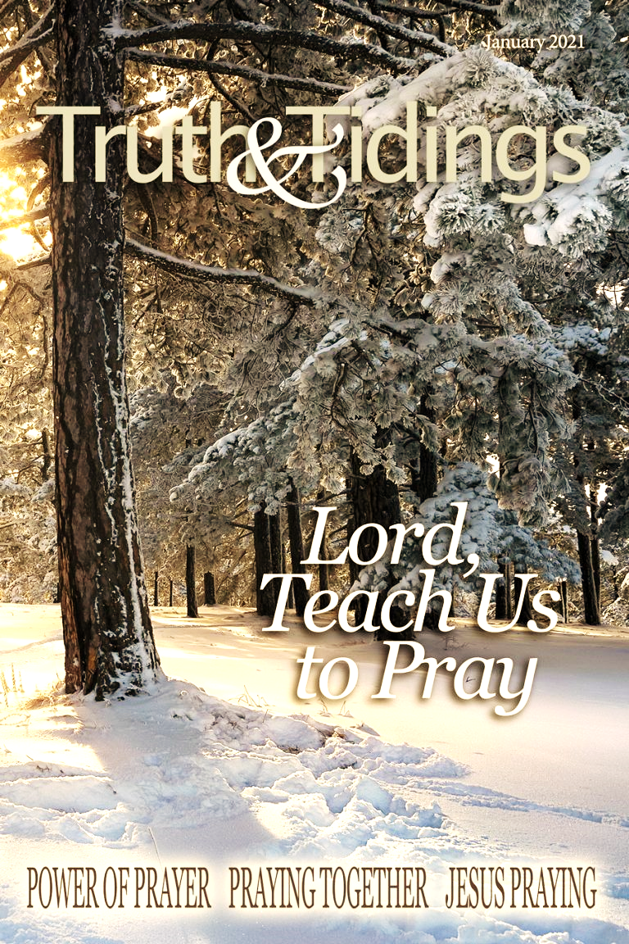

Lord, we come to you in prayer and praise for joy, comfort, and healing for:
- Frank & Dawn Zaruba in the loss of their nephew Nathan.
- MJ a 14-year-old who has a long road to recovery after horrible abuse.
- Alayna, a friend of Bethel’s daughter Tiya, that she come to know the Lord.

- Pam MacDonald’s distant cousin’s family after his sudden death at 46.
- Bethel Donaldson for continued healing of her hip.
- Mike Parish’s friends CJ & Emmott.
- Rik Reed as he recovers from surgery.
- Vanessa Britten’s dad who is experiencing bad side effects from medication.
- Marie Mitter to recover from surgery on November 19.
- Marie Mitter’s nephew Ty who is going through a divorce.
- Vanessa Britten’s sister Colleen for answers to issues she is having.
- Nancy Winter’s sister Ellen recovering from knee replacement.
- Katie Josephs and their family as they grieve John’s passing.
- Nancy DeDecker and Marge Balliette as Marge is on hospice.
- Kim Marcus for her recovery from thumb surgery on October 30.
- Michael Marcus for healing for his toe ulcer.
- Rene Sundling’s son George who has cancer.
- Dan & Judy Grimmer’s son Andrew as he searches for a new job.
- Pastor Greg & Donna as they begin the next chapter of their lives.
- Michael Strasburg still seeking a diagnosis for medical issues.
- Nancy DeDecker’s granddaughter Ana & Nancy’s daughter Laura.
- Mary & Gary Noggle’s son & his family as they deal with a divorce.
- Our Missionary of the Month, Ellis Bosveld with ReachGlobal.
- Strong marriages & family relationships within our church family.
- The economic concerns within our society & for our church.
- For ACEFC to be united in mind & purpose. (1 Corinthians 1:10)
- The Elders of our church to have sound wisdom, knowledge and understanding from God.
- Protection & power for dealing with spiritual battles.
- Our children, grandchildren, parents, teachers, and all school personnel, & government leaders in our country & around the world.
- Our unsaved loved ones, friends, and co-workers.
- God’s protection of Israel and the peace of Jerusalem. (Psalm 122)

Continued prayers for:

Bethel Donaldson’s childcare families, Bruni, Jennifer Zachek, Jay & Sharolyn Hofman, and others in need of healing, financial needs, continued prayers for all our members of our church family, our private personal requests, and our yet to be answered prayers.

Appleton Community EFC

Prayer Requests/Praise

11/23/2025

Lord, we come to you in prayer and praise for joy, comfort, and healing for:
- Frank & Dawn Zaruba in the loss of their nephew Nathan.
- MJ a 14-year-old who has a long road to recovery after horrible abuse.
- Alayna, a friend of Bethel’s daughter Tiya, that she come to know the Lord.

- Pam MacDonald’s distant cousin’s family after his sudden death at 46.
- Bethel Donaldson for continued healing of her hip.
- Mike Parish’s friends CJ & Emmott.
- Rik Reed as he recovers from surgery.
- Vanessa Britten’s dad who is experiencing bad side effects from medication.
- Marie Mitter to recover from surgery on November 19.
- Marie Mitter’s nephew Ty who is going through a divorce.
- Vanessa Britten’s sister Colleen for answers to issues she is having.
- Nancy Winter’s sister Ellen recovering from knee replacement.
- Katie Josephs and their family as they grieve John’s passing.
- Nancy DeDecker and Marge Balliette as Marge is on hospice.
- Kim Marcus for her recovery from thumb surgery on October 30.
- Michael Marcus for healing for his toe ulcer.
- Rene Sundling’s son George who has cancer.
- Dan & Judy Grimmer’s son Andrew as he searches for a new job.
- Pastor Greg & Donna as they begin the next chapter of their lives.
- Michael Strasburg still seeking a diagnosis for medical issues.
- Nancy DeDecker’s granddaughter Ana & Nancy’s daughter Laura.
- Mary & Gary Noggle’s son & his family as they deal with a divorce.
- Our Missionary of the Month, Ellis Bosveld with ReachGlobal.
- Strong marriages & family relationships within our church family.
- The economic concerns within our society & for our church.
- For ACEFC to be united in mind & purpose. (1 Corinthians 1:10)
- The Elders of our church to have sound wisdom, knowledge and understanding from God.
- Protection & power for dealing with spiritual battles.
- Our children, grandchildren, parents, teachers, and all school personnel, & government leaders in our country & around the world.
- Our unsaved loved ones, friends, and co-workers.
- God’s protection of Israel and the peace of Jerusalem. (Psalm 122)

Continued prayers for:

Bethel Donaldson’s childcare families, Bruni, Jennifer Zachek, Jay & Sharolyn Hofman, and others in need of healing, financial needs, continued prayers for all our members of our church family, our private personal requests, and our yet to be answered prayers.

