Appleton Community EFC

Prayer Requests/Praise

10/19/2025

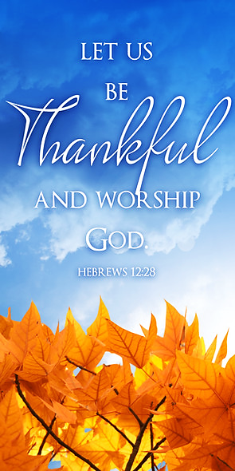

Lord, we come to you in prayer and praise for joy, comfort, and healing for:
- Kim Marcus for her thumb surgery on October 30.
- Michael Marcus for healing for his toe ulcer.
- Yon Abel’s friend whose son is suicidal.
- Yon Abel’s mother-in-law who is experiencing neurological changes.
- John & Katie Josephs as John is now on hospice.
- Pam MacDonald’s mom with stage 1 breast cancer.
- Nancy DeDecker’s friend Leose as she has breast and appendix cancer.
- Anita St. Ours who has a fractured foot.
- Gary Noggle as he waits for the results of a spinal tap.
- Rene Sundling’s son George who has cancer.
- Dan & Judy Grimmer’s son Andrew as he searches for a new job.
- Pastor Greg & Donna as they begin the next chapter of their lives.
- For young adults in our area who are struggling with their faith.
- Josh Turkow’s stepmother Carol who has completed chemo; continued prayers for many years of remission.
- Michael Strasburg still seeking a diagnosis for medical issues.
- Nancy DeDecker’s granddaughter Ana & Nancy’s daughter Laura.
- Mary & Gary Noggle’s son & his family as they deal with a divorce.
- Strong marriages & family relationships within our church family.
- The economic concerns within our society & for our church.
- For ACEFC to be united in mind & purpose. (1 Corinthians 1:10)
- The Elders of our church to have sound wisdom, knowledge and understanding from God.
- Protection & power for dealing with spiritual battles.
- Our children, grandchildren, parents, teachers, and all school personnel,

government leaders in our country & around the world. (Prov. 21:1)
- Our unsaved loved ones, friends, and co-workers.
- God’s protection of Israel and the peace of Jerusalem. (Psalm 122)

Continued prayers for:

Marge Balliette, Bethel Donaldson’s childcare families, Bruni, Jennifer Zachek, Jay & Sharolyn Hofman, and others in need of healing, financial needs, continued prayers for all our members of our church family, our private personal requests, and our yet to be answered prayers.

Appleton Community EFC

Prayer Requests/Praise

10/19/2025

Lord, we come to you in prayer and praise for joy, comfort, and healing for:
- Kim Marcus for her thumb surgery on October 30.
- Michael Marcus for healing for his toe ulcer.
- Yon Abel’s friend whose son is suicidal.
- Yon Abel’s mother-in-law who is experiencing neurological changes.
- John & Katie Josephs as John is now on hospice.
- Pam MacDonald’s mom with stage 1 breast cancer.
- Nancy DeDecker’s friend Leose as she has breast and appendix cancer.
- Anita St. Ours who has a fractured foot.
- Gary Noggle as he waits for the results of a spinal tap.
- Rene Sundling’s son George who has cancer.
- Dan & Judy Grimmer’s son Andrew as he searches for a new job.
- Pastor Greg & Donna as they begin the next chapter of their lives.
- For young adults in our area who are struggling with their faith.
- Josh Turkow’s stepmother Carol who has completed chemo; continued prayers for many years of remission.
- Michael Strasburg still seeking a diagnosis for medical issues.
- Nancy DeDecker’s granddaughter Ana & Nancy’s daughter Laura.
- Mary & Gary Noggle’s son & his family as they deal with a divorce.
- Strong marriages & family relationships within our church family.
- The economic concerns within our society & for our church.
- For ACEFC to be united in mind & purpose. (1 Corinthians 1:10)
- The Elders of our church to have sound wisdom, knowledge and understanding from God.
- Protection & power for dealing with spiritual battles.
- Our children, grandchildren, parents, teachers, and all school personnel,

government leaders in our country & around the world. (Prov. 21:1)
- Our unsaved loved ones, friends, and co-workers.
- God’s protection of Israel and the peace of Jerusalem. (Psalm 122)

Continued prayers for:

Marge Balliette, Bethel Donaldson’s childcare families, Bruni, Jennifer Zachek, Jay & Sharolyn Hofman, and others in need of healing, financial needs, continued prayers for all our members of our church family, our private personal requests, and our yet to be answered prayers.

